Information Architecture
Your Project Toolkit

How to Use This Toolkit
To get started with this toolkit:
- Click File > Make a copy… in the upper-left corner.
- Give the file a title that includes your first and last name.
- Click OK.
- The toolkit is now saved to your Google Drive account, where you’ll be able to edit it.
Your Project Challenge
In your initial user research, you “conduct user research and synthesize your findings to produce project deliverables including a user persona and a problem statement.”

This toolkit provides the resources to help you:
- Write user goals and task flows.
- Conduct a card sorting exercise.
- Develop a taxonomy for labeling and navigation.

Storyboard
Refer to the template below to sketch out a storyboard specific to a user goal.

PROJECT NAME: Travelers “R” U
USER GOAL: To successfully curate and come up with a personalized itinerary. | 7/15/2020
1  Log into your travel agency’s website on your computer.  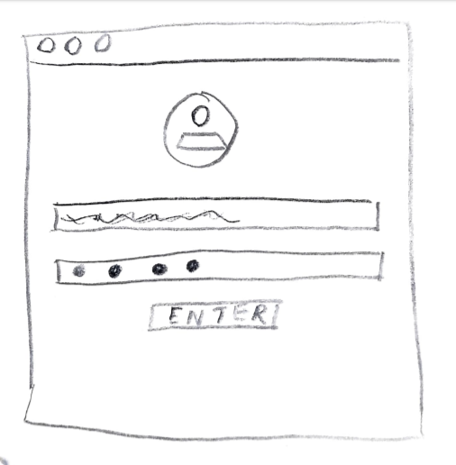 | 2  Find the workplace that allows you to design your own customized itinerary and open it.  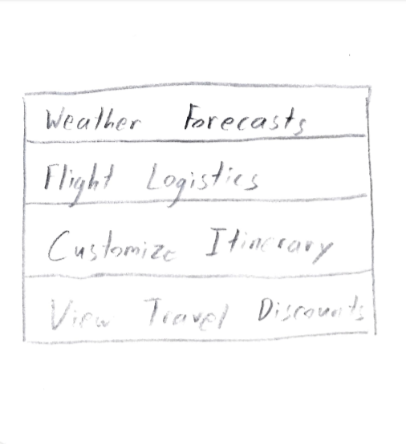 | 3  Gather all the information you may need to make your itinerary: flights, hotels, day trip information, etc.  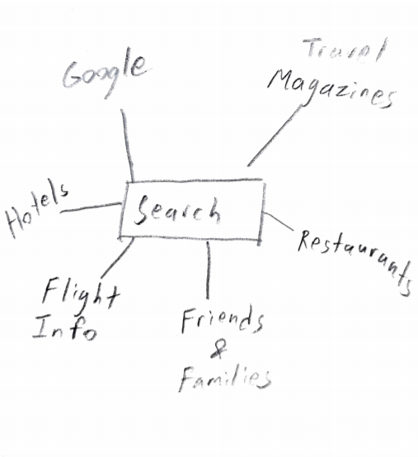
4  Start filling in day-to-day information.  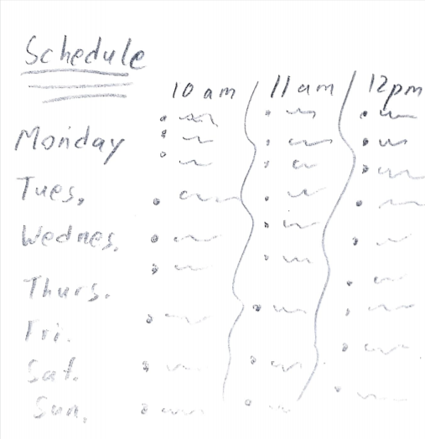 | 5  Send your custom-made itinerary to yourself.   | 6  Store your itinerary for further revisions.  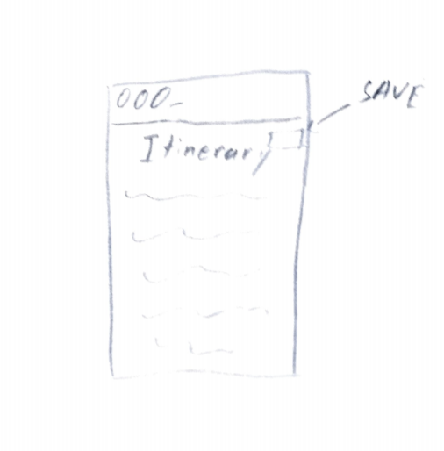

User Flows
You don’t need fancy tools to create a comprehensive user flow!

With a tool of your choice, write out the task being illustrated, export your user flow as a PNG or JPEG file, and insert it below. Keep in mind that you might have more than one task per user goal.

Task: (Write out the task here in 1–2 sentences.)

- Log into your travel agency’s website on your computer.
- Find the workplace that allows you to design your own customized itinerary and open it.
- Gather all the information you may need to make your itinerary: flights, hotels, day trip information, etc.
- Start filling in day-to-day information.
- Send your custom-made itinerary to yourself.
- Store your itinerary for further revisions.
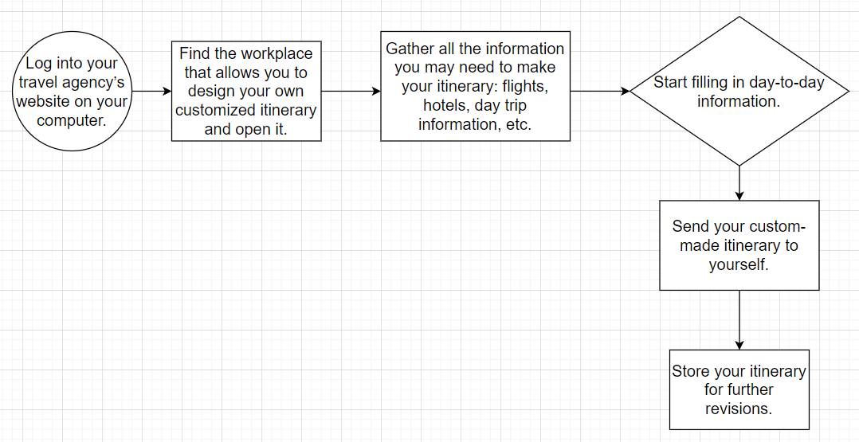

Card Sort Report

PROJECT NAME: Travelers “R” U
FACILITATOR: Wei Da Chen
SUMMARY
The facilitator conducted an open card sort with 10 cards and a total of 14 participants. The card sort was conducted using the online software “Optimal Workshop”.
TEST OBJECTIVE
The card sort was conducted to help shape the information architecture for the design of a mobile and web app that provides transportation information and curated itineraries and uncover how intended users expect to see content and information organized on the product’s website or app.
PARTICIPANTS
The total number of individuals who attempted the card sort was 14.
The total number of individuals who successfully completed the card sort was 10.
DATA COLLECTED
The facilitator collected qualitative and quantitative data:
- Qualitative Data:
- “Some cards had a strong connection to each other while some do not.”
- “I chose the moving group because a lot of the cards associated with things in travel. These include modes of flight and transportation.”
- Quantitative Data:
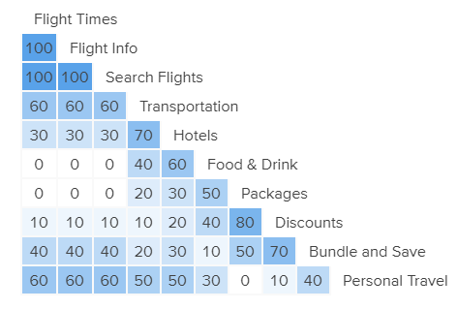
TOP 10 GROUPINGS  - Flight Times  - Flight Info  - Discounts  - Packages  - Search Flights  - Hotels  - Bundle and Save  - Food and Drink  - Transportation  - Personal Travel |  | TOP 10 CATEGORIES (if performing an open card sort)  - Moving  - Airplane  - Travel  - Destination Stuff  - Things To Do  - Logistics  - About The Flight  - Leisure  - Personal Things  - Transportation
RESULTS
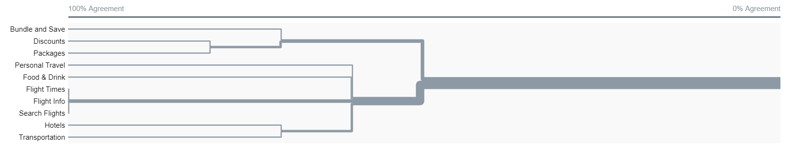
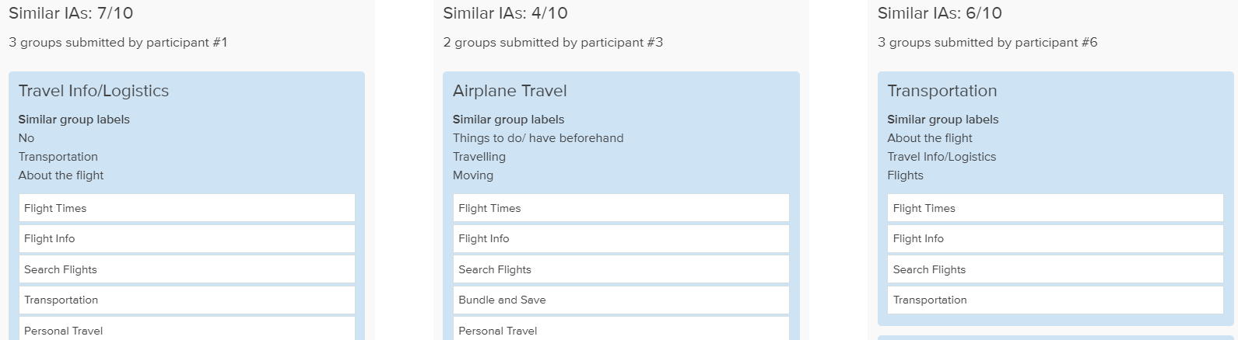

RECOMMENDATIONS
- Everything relating to flights should be in one category instead of being scattered in multiple categories in the site/app.
- Discounts and Bundles & Save should fall under one category as they relate to savings.

APPENDIX
- https://0kv5gj76.optimalworkshop.com/optimalsort/bo3e5ueu
- 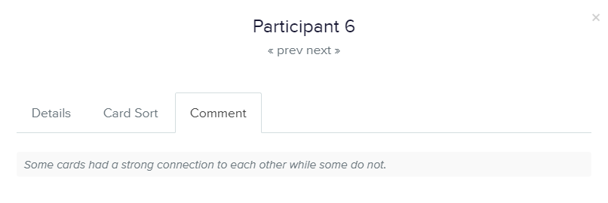

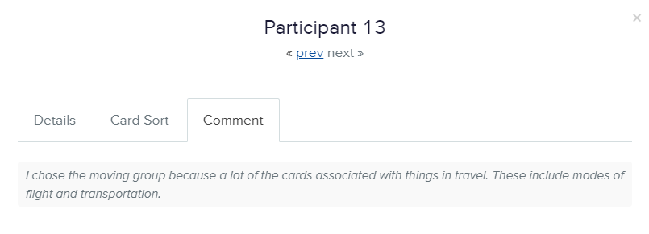

Sitemap
Using a tool of your choice, create a digitized version of your sitemap, export it as a PNG or JPEG, and insert it below.

NAME OF PROJECT: Travelers ”R” U

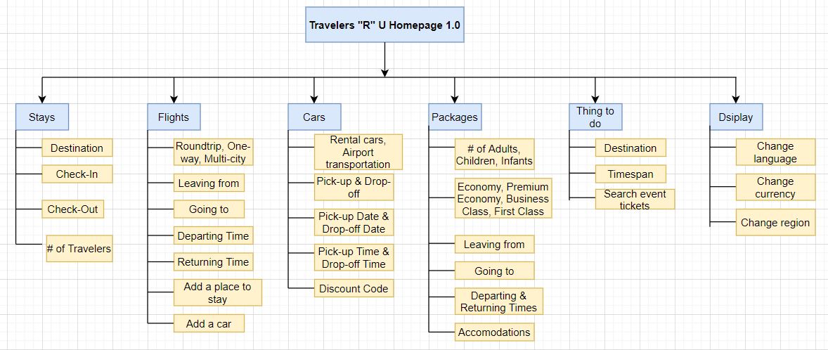

Quality Checks
Congratulations! You’ve just completed your information architecture project. Now it’s time to give your project deliverables a thorough review before sharing them with your mentor and/or peers. Review the bullets below to ensure that your deliverables meet basic expectations.

Deliverable 1: Storyboard
Meeting Expectations
- The storyboard illustrates a complete series of events or actions a user takes to achieve a goal.
- The illustrations are placed in a sequential order.

Deliverable 2: User Flow(s)
Meeting Expectations
- The presentation of user flow includes the task and the consistent and correct use of key shapes and arrows.
- The user flow contains an entry point and an exit point.
- The user flow represents decisions with more than one option to complete the selected task.

Deliverable 3: Card Sort Report
Meeting Expectations
- One round of open or closed card sort is complete with five or more participants.
- A minimum of 30 cards were created.
- The card sort report contains all of the information required by the report template, along with well-written and summarized results and recommendations.

Deliverable 4: Sitemap
Meeting Expectations
- The sitemap is complete and accurately describes the content hierarchy.
- Each screen/page of the sitemap is clearly labeled.
- The sitemap includes two or more levels of hierarchy.

